

***Trusted to Deliver Excellence***



**Kuwaiti Digital Computer Co.**

**Profile 2020**

Company Profile

|  |  |
| --- | --- |
| **INDEX** |  |
| Company Overview | …………………………………………………………………… |
| Board of Directors | …………………………………………………………………… |
| Mission & Vision | …………………………………………………………………… |
| Organization Chart | …………………………………………………………………… |
| Strategic Partners | …………………………………………………………………… |
| Industries and Sectors | …………………………………………………………………… |
| KDCC Strength | …………………………………………………………………… |
| Scope & Specializations | …………………………………………………………………… |
| Projects | …………………………………………………………………… |
| Contact Information | …………………………………………………………………… |

Company Overview

KDCC is a leading technology services provider, delivering innovative business solutions and offering a comprehensive spectrum of IT solutions.

KDCC is a closed shareholders company, financially stable, with a paid capital of KWD 3,840,408.000 (Three Million Eight Hundred Forty Thousand and Four hundred Eight Kuwaiti Dinars) was founded on the principles of innovation and investing on creative ideas.

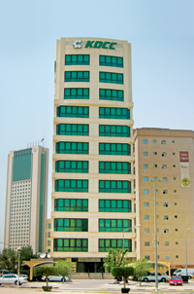Since its establishment in 1978, KDCC has been having a high reputation amongst its many prestigious clients in Kuwait in regards of high-quality technical support, delivering state of the art products and carrying out high quality services to the customers.

KDCC has grown into a profitable multimillion-dollar turnover company employing over 100 professionals and senior specialists highly qualified with a set of internationally recognized product certifications.

KDCC as a leading solution provider with more than 40 years’ experience and partnership with world leaders in technology guarantees the most reliable customer services and solutions at all levels of computerization. The services of KDCC span throughout the entire IT lifecycle, which include Assessments, Infrastructure Design and Implementation, Business Productivity Solutions, Training Services, IT Operations and Management Services. The high-end expertise of KDCC in outsourcing has contributed in bridging the gap between business and information technology driven goals.

Investing heavily on yearly basis in training and certifications, KDCC achieved highest partnership level with many top vendors. Over hundred onboard highly trained and qualified professionals are distributed in the following departments:

* A picture containing light, green, traffic, street

  Description automatically generatedManagement
* Sales & Marketing
* Administration & Finance
* Project Management
* Tender & Presales
* Technical Departments:
* Hardware Division.
* Network Division.
* Software Division.
* Security Division.
* Professional Service Centre.

KDCC has achieved ISO 270001, ISO 9001:2015 and ISO 20000 certifications.

|  |  |  |
| --- | --- | --- |
| Image result for isoqar 27001 logo | Image result for iso 9001:2015 intertek | Image result for isoqar 20000 logo |

Board of Directors

|  |  |
| --- | --- |
| * **Mr. Khalid Faisal Al-Qatami** | **Chairman & CEO** |
| * **Mr. Badr Naser Al-Hajery** | **Deputy Chairman** |
| * **Mr. Khalid Al Nisf** | **Board Member** |
| * **Mr. Yousef Faisal Al-Qatami** | **Board Member** |
| * **Mr. Mohammed Al Thuwaini** | **Board Member** |
|  |  |

Mission & Vision

KDCC mission is turning the customer objectives into reality using the power of information technology and building a high-quality and comprehensive technology infrastructure. Moreover, KDCC works on establishing and upholding an effective/efficient operational environment, deliver quality, prompt, cost-effective and reliable set of technology services and solutions.

The vision of KDCC is to create an environment where the community can have an easy access to the most trending technology resources and solutions and to expand our business throughout the Middle East region. Developing and establishing a beneficial long-term relationship with our customers in a spirit of collaboration.

Organizational Chart

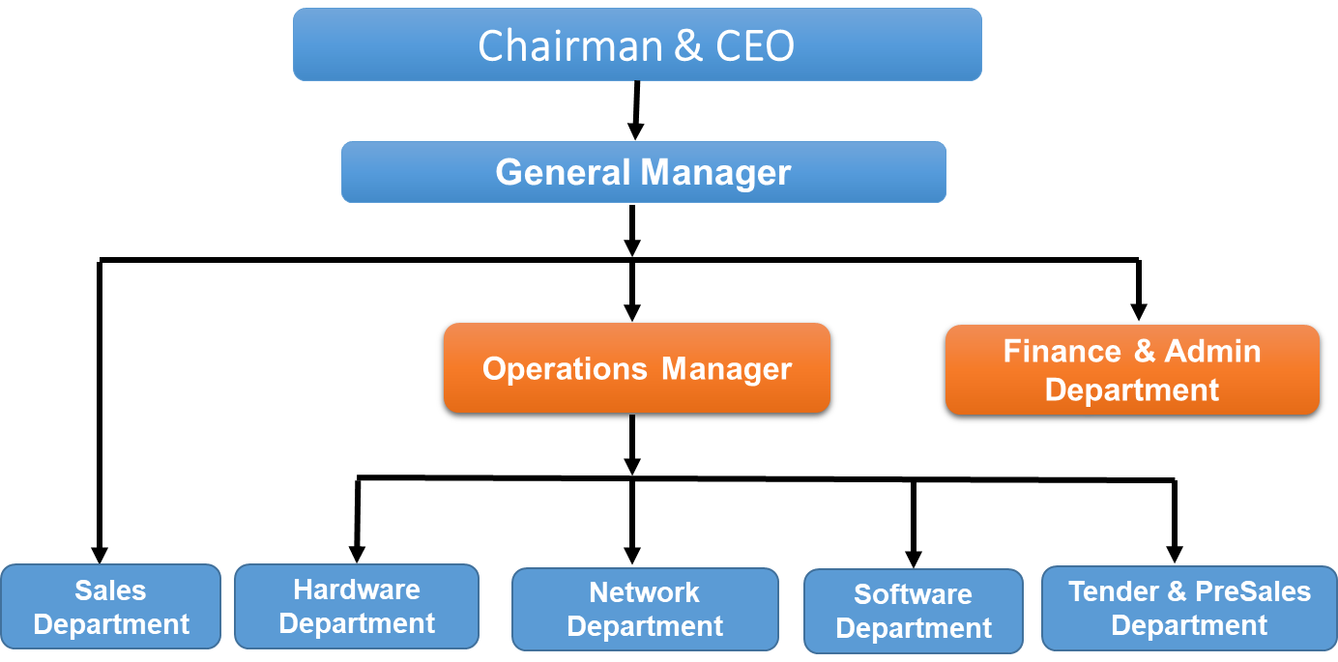

Strategic Partners

|  |  |
| --- | --- |
|  | Hewlett Packard Enterprise has been in the innovation business for more than 75 years. With a wide portfolio and global research and development capabilities HPE is part of an innovation roadmap designed to help organizations of all sizes – from global enterprises to local startups – transition from traditional technology platforms to the IT systems of the future. HP Enterprise delivers high-quality, high-value Servers, Storage & Networking products, consultation and support services in a single package. HPE has industry-leading positions in servers, storage, wired and wireless networking, converged systems, software, services and cloud. With customized financing solutions and strategy, HPE provides the right tech solutions for unique business goals. |
|  | Hewlett Packard Inc. popularly called HP provides technology solutions to consumers, business organizations and institutions worldwide. The company expands its operations to IT infrastructure, personal computing and access devices, global services, imaging and printing services. HP is operating in more than 170 countries around the world. The mission of the company is to facilitate technology and services that can assist individuals and institutions in addressing their problems and challenges so as to realize their dreams. |
| http://www.teklinks.com/wp-content/uploads/2017/03/Cisco-Gold-Partner-Logo.png | Cisco was founded in 1984 by a small group of computer scientists from Stanford University. Since the company's inception, Cisco have been leaders in the development of Internet Protocol (IP)-based networking technologies. Today, with more than 71,000 employees worldwide, this tradition of innovation continues with industry-leading products and solutions in the company's core development areas of routing and switching, as well as advanced technologies such as home networking, IP telephony, optical networking, security, Server technologies, and wireless technology. In addition to its products, Cisco provides a broad range of service offerings, including technical support and advanced services. |
|  | Microsoft mission is to empower every person and every organization on the planet to achieve more. The mission is grounded in both the world in which we live and the future we strive to create. Today, we live in a mobile-first, cloud-first world, and the transformation we are driving across our businesses is designed to enable Microsoft and our customers to thrive in this world. Microsoft do business in 170 countries and are made up of 114,000 passionate employees dedicated to fulfilling mission of helping people and their organizations achieve more. |
| Image result for oracle gold partner png | Oracle leading the cloud, from intelligent business applications to infrastructure, Oracle delivers tomorrow’s emerging technologies today, like the world’s first - and only - autonomous database. Also, Oracle leads in enterprise, software, applications, database, middleware, fusion, business intelligence, Primavera, PeopleSoft, EPM, BEA, Hyperion, Retek, Utilities, On-Demand, server &amp; storage systems, BPM, solutions for communications industry, ERP, CRM, CRM On Demand, JDE and Siebel. |
| Image result for fortinet logo | Fortinet secures the largest enterprise, service provider, and government organizations around the world. Fortinet empowers its customers with intelligent, seamless protection across the expanding attack surface and the power to take on ever-increasing performance requirements of the borderless network - today and into the future. Only the Fortinet Security Fabric architecture can deliver security without compromise to address the most critical security challenges, whether in networked, application, cloud or mobile environments. Fortinet specializes in Network Security, Enterprise Firewall, Unified Threat Management (UTM), Firewall, Intrusion Prevention System (IPS), VPN, Antivirus, Email security, Web filtering and Web Security Gateway, Antispam, Application Control and Visibility, Next Generation Firewall (NGFW) |
|  | VMware, a global leader in cloud infrastructure and digital workspace technology, accelerates digital transformation by enabling unprecedented freedom and flexibility in how customers build and evolve IT environments. with VMware solutions, organizations are improving business agility by modernizing data centers and integrating public clouds, driving innovation with modern apps, creating exceptional experiences by empowering the digital workspace, and safeguarding customer trust by transforming security.. |
|  | PaloAlto is the global cybersecurity leader across clouds, networks, and mobile devices, known for always challenging the security status quo. its mission is to protect our way of life in the digital age by preventing successful cyberattacks. This has given the privilege of safely enabling tens of thousands of organizations and their customers. The pioneering Security Operating Platform emboldens their digital transformation with continuous innovation that seizes the latest breakthroughs in security, automation, and analytics.  Paloalto specializes in Security Operating Platform, Cloud Security, SaaS Security, Network Security, Next-Generation Firewall, Cybersecurity, Threat and Malware Prevention, URL Filtering, Threat Intelligence, Enterprise Security Platform and Endpoint Security. |
|  | Citrix is a digital workspace platform that gives employees everything they need to be productive in one unified experience with the visibility, simplicity, and security needed Citrix aims to power a world where people, organizations and things are securely connected and accessible to make the extraordinary possible providing a comprehensive secure digital workspace that unifies the apps, data and services and simplifies IT’s ability to adopt and manage complex cloud environments |
| Image result for nexthink partner logo | Nexthink is an IT solutions company in the business, they provide transformative solutions via real-time analytics, instant remediation, automation, and employee feedback across all the endpoints in your digital workplace. |
| Image result for f5" | F5 gives its customers the freedom to securely deliver every app, anywhere with confidence. All F5 products are highly programmable and integrate into any environment, whether on premises or in any cloud. To date, 48 of the Fortune 50 companies rely on F5 to deliver apps that customers and employees can securely access at any time, on any device, from any location.  F5 specializes in Application Delivery, Web Acceleration, Security, Load-balancing, WAN Optimization, High Availability, SSL VPN, Network Traffic Management, Network Hardware, Cybersecurity, DDoS Protection, Cloud Computing, Application Availability, WAF, Application Security, Identity and Access Management |
|  | SolarWinds is a IT service management solutions company that develops software for businesses to help manage their networks, systems, and information technology infrastructure. SolarWinds Network Management tools helps to monitor and respond to problems across all IT Infrastructure devices. |
|  | Trend Micro is a global leader in network antivirus and Internet content security software and services. we focus on outbreak prevention & providing customers with a comprehensive approach to managing the outbreak lifecycle and the impact of network worms and virus threats. In 1988, Trend Micro developed antivirus software—but it didn’t stop there. Over the last three decades, they became a market leader in hybrid cloud security, network defense, small business security, and endpoint security. |
|  | Red Hat is a multinational software company providing open source software products to the enterprise community. Red Hat is the world's leading provider of enterprise open source operating Systems, including high-performing Linux, cloud, container, and Kubernetes technologies. |
| Image result for Mcafee logo | McAfee provides advanced [security solutions](https://www.mcafee.com/enterprise/en-us/solutions.html) to consumers, small and large businesses, [enterprises](https://www.mcafee.com/enterprise/en-us/products.html), and governments. Security technologies from McAfee use a unique, predictive capability that is powered by [McAfee Global Threat Intelligence](https://www.mcafee.com/enterprise/en-us/threat-center/threat-landscape-dashboard.html), which enables home users and businesses to stay one step ahead of the next wave of file-less attacks, viruses, malware, and other online threats. |
| Image result for symantec logo | Symantec is the the cyber defense platform powered by the world's largest and dynamic civilian threat intelligence network. Symantec provides security products and solutions to protect small, medium, and enterprise businesses from advanced threats, malware, and other cyber defense solutions. |
|  | Adobe is a multinational computer software company. It has historically focused upon the creation of multimedia and creativity software products and more recently towards digital marketing software through digital experiences to help customers create, deliver and optimize content and applications. |
|  | A10 Networks is a provider of intelligent and automated cybersecurity solutions, providing a portfolio of high-performance secure application solutions that enable intelligent automation with machine learning to ensure business critical applications are protected, reliable and always available. Founded in 2004, A10 Networks is based in San Jose, Calif., and serves customers in more than 80 countries with offices worldwide. A10's mission is to protect our customers with best-in-class solutions and services needed to win the cyberwar, to enable intelligent automation with machine learning to ensure business critical applications are protected, reliable and always available. |
| Image result for Autodesk logo png | Autodesk is a software corporation that makes software services for the architecture, engineering, construction, manufacturing, media, education, and entertainment industries. Autodesk makes software like AutoCAD, Revit, Maya, 3ds Max, Fusion 360, SketchBook, and many more to unlock the creativity and solve important design, business and environmental challenges. |
|  | Veeam is the global leader in intelligent data management for the Hyper-Available Enterprise. Founded in 2006, Veeam has more than 300K customers worldwide, 55K channel partners, Cisco, HPE, and NetApp as exclusive resellers and nearly 19,000 cloud and service providers. As the leader in Availability across multi-cloud environments and a Forbes Cloud 100 company, Veeam is uniquely positioned to help customers along their journey to Intelligent Data Management. Veeam is trusted by 75% of the Fortune 500 and recognized as a Leader in the 2017 Gartner Magic Quadrant for Data Center Backup and Recovery. |

Industries & Sectors

|  |  |  |  |
| --- | --- | --- | --- |
|  | **Governmental Sector** |  | **Oil/Gas Sector** |
|  | **Airlines Sector** |  | **Telecom Sector** |
|  | **Educational Sector** |  | **Banking Sector** |
|  | **Investment Sector** |  | **Healthcare Sector** |
|  | **Retail Sector** |  | **Manufacturing Sector** |

KDCC Strengths

* A remarkable presence in the market. KDCC owns a partnership with the following:
* HP Inc. (Gold Partner)
* HPE (Highest Vendor Partnership level HPE Platinum Partner)
* Cisco (Cisco Gold Partner)
* Microsoft (MS Gold)
* Dedicated Staff for HPE, HP Inc. and Cisco Service Centre.
* Dedicated Sales/Pre-sales engineers for assessment.
* Sizing and solution designs by involving with +40 of the most advanced and trending technologies.
* A group of IT Professionals and seniors certified engineers for solution deployment and post implementation support (CCIE –CCNP – HPE ASE – MASE –ITIL –HP ASP – MS Datacentre Solutions –Datacentre Expert) Authorized Support Center – (HP Inc., HP Enterprise & Cisco).
* KDCC is the only Authorized Service Center for HPE in Kuwait and owns the ability to provide the required support services and End to End IT Infrastructure Solutions within HPE portfolio with availability of professional local resources & extensive capabilities in Design, Consultancy, Implementation, Testing & Support Services.
* KDCC has high level HPE product Specializations and excellent reputation in the market.
* KDCC has large customer base where we have implemented HPE hardware and software solutions.
* KDCC has prepared the plan to focus on Consolidation & Virtualization (converged Infrastructure), Data Security and high availability (Backup & Disaster Recovery) as well as latest technology-based SAN Storage & Composable Infrastructure projects for 2020.
* KDCC has the ability to provide End to End technology Solution within HP Inc. portfolio with availability of professional resources, HP certified engineers and technicians as well as the best level of Implementation & Support Services.
* KDCC has the "Collective Purchase" contract with Ministry of Finance Kuwait for the procurement, delivery, deployment Implementation and support of HP Inc. products for example: PCs, Desktops, Laptops, Printers, Scanners etc. for the public sector, the contract has been successfully managed, maintained and renewed since last 5 years.
* KDCC has the ability to provide End to End Network infrastructure and Security Solutions and the best level of Implementation & Support Services. KDCC is a highly experienced Partner for Cisco maintaining its Gold level partnership since more than 10 years along with dedicated Cisco Specialized team for presales, Project implementation and technical support services.
* KDCC maintains highly certified engineers & technicians (CCIE and CCNP) with a wide range of Cisco products Specialization. KDCC has a long list of customers site references where we have implemented Cisco Network Infrastructure and network security solutions.
* KDCC have acquired and maintained several specializations and competencies and have a long list of successful project implementations for Microsoft products and end to end migrations projects, for the year 2020 focusing on Virtual Desktop solutions and Hyper-V server’s virtualization as well as Microsoft Azzure Cloud services. Business with Microsoft for 2019 is satisfactory, seeking for more projects and opportunities for next year.
* KDCC has more than 40 projects for VMware solutions and planning for next year to focus on VMware Server virtualization, VDI and Cloud opportunities.
* 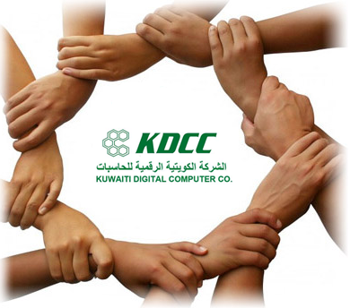Ability to manage large turnkey projects.
* Robust infrastructure solutions provider.
* Well-operated helpdesk system.
* Financial stability.

Scope & Specialization

* **Network & Security**
  + Switching & Routing
  + Wireless Network
  + Network Securities
  + IP Telephony & Smart Meeting
* **Compute Systems**
  + Hyper Converged Solution
  + Servers Virtualizations
  + Business Critical System
  + Enterprise SAN Storage
* **Cloud Services** 
  + On Premises Hybrid Cloud
  + Amazon Cloud Services
  + Cloud Backup & Securities
  + Cloudera & MS Azure Stack
* **Data Center & Big Data**
  + Data Center Design & Management
  + ERP, BI & VDI Solutions
  + DR & Business Continuity
  + Data Migration
* **Service Delivery Management**
  + Managed Services
  + Authorized Service center
  + Outsourcing
  + Proactive Care & Consultancy

Projects

**Turnkey Projects**

|  |  |
| --- | --- |
| Turnkey Projects | Projects Delivered |
| Microsoft Infrastructure solutions | 100 |
| Servers Consolidation & Virtualization | 75 |
| Network Infrastructure Solutions | 70 |
| Support, Maintenance Managed Services | 50 |
| Wireless Network & NW Security | 30 |
| IP Telephony and Smart Meeting | 25 |
| Local & Hybrid Cloud Solutions | 7 |
| Business Continuity – DR | 5 |

**Recent Projects**

|  |  |
| --- | --- |
| Recent Projects | Details |
| Kuwait Oil Company | SCADA network infrastructure upgrade and support |
| KIPIC | Outsourcing HP PCs , printers and support |
| KNET | HPE Integrity Nonstop, transactions Intensive solution. |
| Boursa Kuwait | Complete Hardware, Network, security & system management Infrastructure |
| Al-Zour Refinery | Servers, Enterprise SAN Storage, backup and disaster recovery solution. |
| KIA | Complete datacentre revamp with HPE Synergy Solution and HPE 3par Enterprise SAN Storage. |
| KIB | Complete IP telephony project. |
| Garden-Inn Hotel | Complete Network, Securities & Wireless Network Infrastructure. |
| Hayat Hotel | Complete Network, Securities & Wireless Network Infrastructure. |
| Zain | HPE Apollo Cloudera Big data Infrastructure, VMware Hybrid Cloud solution. |
| Credit Bank | Cisco Hyperflex for SAP HANA. |
| Capital Markets Co. | Leasing & outsourcing. |
| KDIPA | Complete Datacenter HPE Synergy Composable Solution. |
| CSC | Enterprise SAN Storage and HPE Integrity Solution. |
| MOF | HPE Integrity high-end Servers. |
| Commercial Facilities | Cisco Hyperflex for SAP HANA. |

**Site References for Mega Projects**

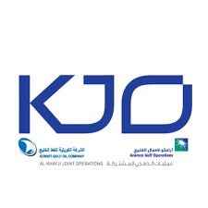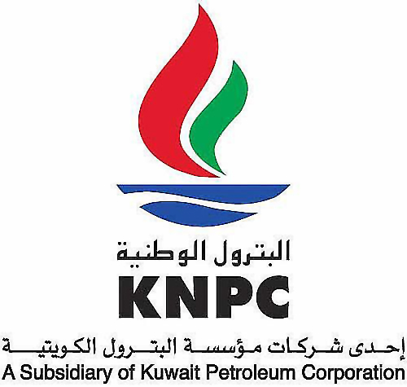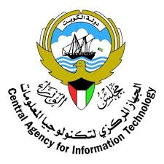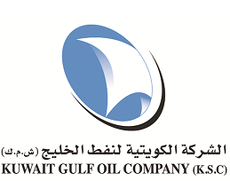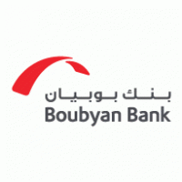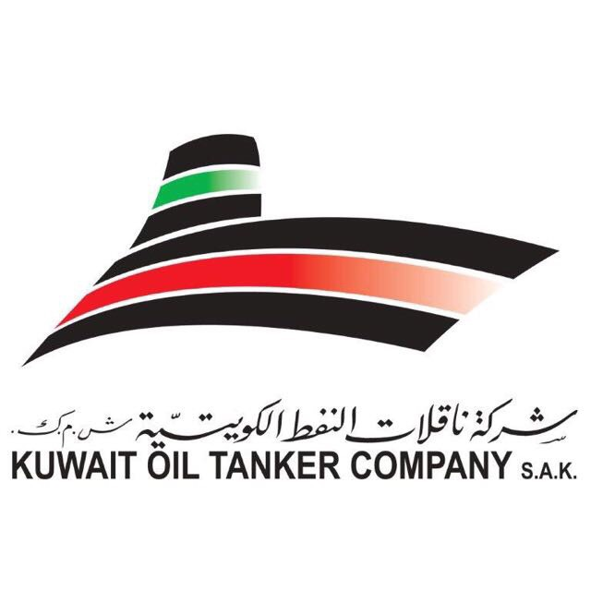

Contact Information

|  |  |  |  |  |  |  |  |  |  |  |  |  |  |  |  |  |  |  |
| --- | --- | --- | --- | --- | --- | --- | --- | --- | --- | --- | --- | --- | --- | --- | --- | --- | --- | --- |
| **Physical Address:**  Kuwaiti Digital Computer Company (KDCC)  KDCC Tower, Magwa East, Sharq – Kuwait  P.O. Box: 25337 - Safat 13114 – Kuwait   |  |  |  | | --- | --- | --- | |  | +965 1820004 | | | https://encrypted-tbn0.gstatic.com/images?q=tbn%3AANd9GcQow5E4YcpqszbHS6FcwD4g1lOgVgvzfPfL0MU0gxpzWa-sl6ys | +965 2240 7038 | | | D:\Users\mrw899\AppData\Local\Microsoft\Windows\INetCache\Content.MSO\C62F92F.tmp | [info@kdcc.com](mailto:info@kdcc.com) | | |  | [www.kdcc.com](http://www.kdcc.com) | | | D:\Users\mrw899\AppData\Local\Microsoft\Windows\INetCache\Content.MSO\F539B698.tmp | Kuwaiti Digital Computer Company - KDCC | | | Image result for fb logo" | Kuwaiti Digital Computer Company - KDCC | |  |

© 2020 Kuwaiti Digital Company – KDCC. All Rights Reserved.